The Portage Metropolitan Housing Authority’s proposed 2023 Moving to Work Annual Plan is available for public review and comment from August 12, 2022 to and including September 12, 2022. A public hearing discussing the Annual Plan will be held at the PMHA office, 2832 State Route 59, Ravenna, Ohio on Monday, September 12, 2022 at 2:00 p.m.

A draft of the Portage Metropolitan Housing Authority’s proposed 2023 Moving to Work Annual Plan is available for review online at PMHA’s website, at http://www.portagehousing.org.

A copy of the 2023 Annual Plan is available upon request by e-mail to cbudd@portagehousing.org or at the office address listed above. Questions or comments should be directed to Carolyn Budd, Special Programs Manager.
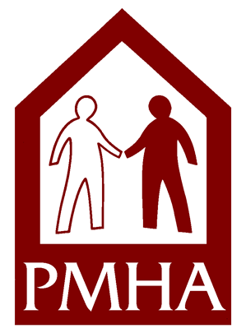
Portage Metropolitan Housing Authority
2832 State Route 59
Ravenna, Ohio 44266
Phone: (330) 297-1489
Website: www.portagehousing.org

