NACA free homEbuyer workshop
- No Down Payment
- No Closing Costs
- No Fees
- Below Market Fixed Rate
- No Perfect Credit Needed
www.NACA.com or call 425-602-6222

Next NACA workshop: Friday April 14, 2023, 10:00 AM-1:00 PM

Portage Metropolitian Housing Authority
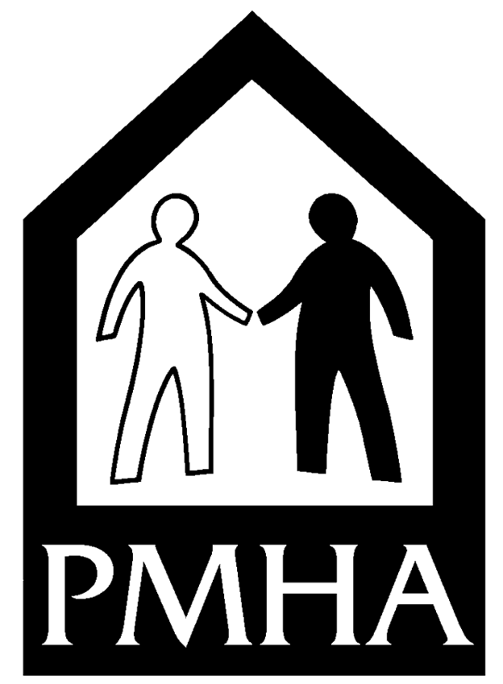
2832 State Route 59
Ravenna, OH 44266
RSVP Kelley Pesicek 330-297-1489 Ext 215
Email: kpesicek@portagehousing.org
